**API Ticket:**

1. **New ticket**

|  |  |
| --- | --- |
| Request URL | http://uat-ims.enrichcous.com/api/ticket |
| Request Method | POST |
| Request Content-Type | application/json; charset=utf-8 |
| Response Content-Type | application/json; charset=utf-8 |
| Request Data : Sample | {  **"ticket_id": null,**   "title": " XXXXXX ",  "description": " XXXXXX ",  "store_id": " XXXXXX ",  "priority": "Low",**//Low || Medium || Hight || Urgent**  "attachments": ["XXXXXX", "YYYYYY", ...], **// Full URL**  "type": "SALES", **// SALES || TECH || ADMIN => create group**  } |
| Response Data: Success | {  "status": "success",  "message": "",  "ticket" : {  "ticket_id": 1234,  "title": "XXXXXX",  "description": " XXXXXX ",  "store_id": " XXXXXX ",  "priority": " XXXXXX ",  **"type": "Support",**  **“status” : “Open”,**  "attachments": ["XXXXXX", "YYYYYY", ...],  "feedbacks": []  }  } |
| Response Data: POS Data Error | {  "status": "error",  "message": " xxx item error/invalid", } |
| Response Data: IMS Server Error | {  "status": "error",  "message": "{Exception message}",  "message_detail": "{Exception trace error message}", } |

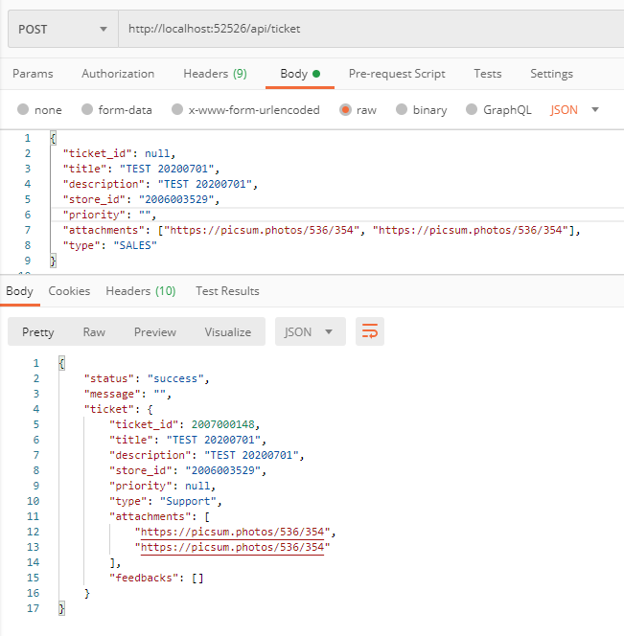

1. **New Ticket Feedback**

|  |  |
| --- | --- |
| Request URL | http://uat-ims.enrichcous.com/api/ticket/newfeedback |
| Request Method | POST |
| Request Content-Type | application/json; charset=utf-8 |
| Response Content-Type | application/json; charset=utf-8 |
| Request Data : Sample | {  "ticket_id": 1234,  **"feedback_id": null,**   "feedback_title": " XXXXXX ",  "feedback_content": " XXXXXX ",  "attachments": ["XXXXXX", "YYYYYY", ...] **// Full URL**  } |
| Response Data: Success | {  "status": "success",  "message": "",  "feedback" : {  "ticket_id": 1234,  "feedback_id": 4321,   "feedback_title": " XXXXXX ",  "feedback_content": " XXXXXX ",  "attachments": ["XXXXXX", "YYYYYY", ...],  } } |
| Response Data: POS Data Error | {  "status": "error",  "message": " xxx item error/invalid", } |
| Response Data: IMS Server Error | {  "status": "error",  "message": "{Exception message}",  "message_detail": "{Exception trace error message}", } |

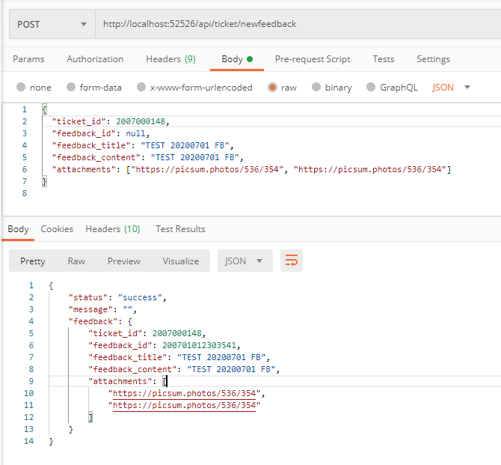

1. **Get by Id**

|  |  |
| --- | --- |
| Request URL | http://uat-ims.enrichcous.com/api/ticket/{ticketId} |
| Request Method | GET |
| Request Content-Type |  |
| Response Content-Type | application/json; charset=utf-8 |
| Request Data : |  |
| Response Data: Exist data | {  "status": "success",  "message": "",  "ticket" :   {  "ticket_id": 1234,  "title": "XXXXXX",  "description": " XXXXXX ",  "store_id": " XXXXXX ",  "priority": " XXXXXX ",  **"type": "Support",**  **“status’ : “Open”, //...**  "attachments": ["XXXXXX", "YYYYYY", ...],  "feedbacks": [  {  "ticket_id": 1234,  "feedback_id": 4321,   "feedback_title": " XXXXXX ",  "feedback_content": " XXXXXX ",  "attachments": ["XXXXXX", "YYYYYY", ...],  },  ...  ]  } } |
| Response Data: not Exist data | {  "status": "error",  "message": "Ticket does not exist! ", } |
| Response Data: IMS Server Error | {  "status": "error",  "message": "{Exception message}",  "message_detail": "{Exception trace error message}", } |

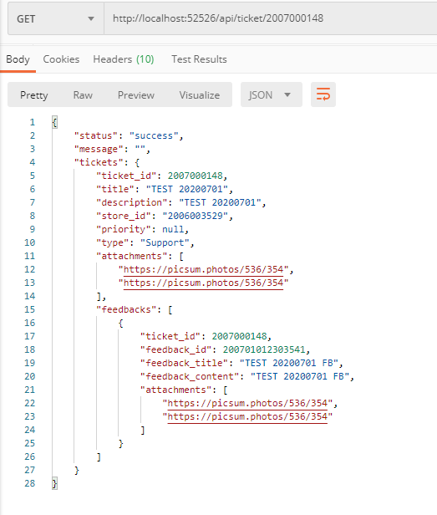

1. **Get all by store id:**

|  |  |
| --- | --- |
| Request URL | http://uat-ims.enrichcous.com/api/ticket/store/{storeId} |
| Request Method | GET |
| Request Content-Type |  |
| Response Content-Type | application/json; charset=utf-8 |
| Request Data : |  |
| Response Data: Exist data | {  "status": "success",  "message": "",  "tickets" : [  {  "ticket_id": 1234,  "title": "XXXXXX",  "description": " XXXXXX ",  "store_id": " XXXXXX ",  "priority": " XXXXXX ",  **"type": "Support",**  **“status”: “Open”,**  "attachments": ["XXXXXX", "YYYYYY", ...],  "feedbacks": [  {  "ticket_id": 1234,  "feedback_id": 4321,  "feedback_content": " XXXXXX ",  "feedback_title": " XXXXXX ",  "attachments": ["XXXXXX", "YYYYYY", ...]  },  ...  ]  },  ...  ] } |
| Response Data: not Exist data | {  "status": "error",  "message": Store does not exist ticket! ", } |
| Response Data: IMS Server Error | {  "status": "error",  "message": "{Exception message}",  "message_detail": "{Exception trace error message}", } |

